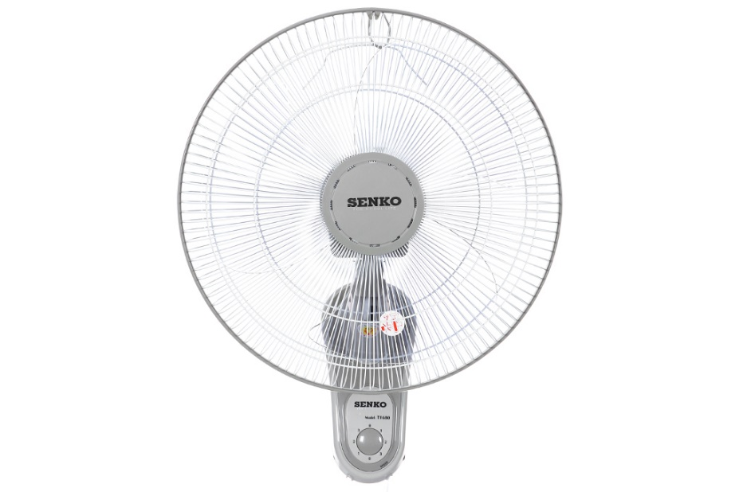

**450.000₫**

**Technical specifications Senko 3-blade wall fan T1680 47W**

* Fan Type:

Wall fan - 47W - 3 wind levels

* Fan diameter:

3 wings - 39 cm

* Wind mode:

Normal wind

* Dashboard:

Zipper

* Motor type:

Silver brazing

* Utilities:

The switch and wire connection protection parts are made of fireproof material. The fan cage has a small fan blade gap

* Size, volume:

Width 44.5 cm - Height 59 cm - Depth 33.5 cm - Weight 3.7 kg

* Brand of:

Vietnam

* Launch year:

2019

Introducing the company 

- Vietnamese brand.

- Established in 1998.

- With the mission "Cooling for life", SENKO electric fans meet all customer needs and are the perfect choice for every home for table fans, hanging fans, mezzanine fans, standing fans, ceiling fans, etc. .

- High quality, beautiful design, and energy saving are the core criteria in every Senko electric fan product.

[***Senko T1680 wall-mounted fan***](https://www.dienmayxanh.com/quat)***has beautiful design, elegant color, harmonious with many usage spaces, effective cooling with 3 blades for 47W capacity, brass motor with 100% durable copper wire, works well. dulcet.***

**Product design**

- [The hanging fan](https://www.dienmayxanh.com/quat-treo-tuong) has a simple design, the body and exterior parts are made of plastic that is easy to clean, so it is gentle when moving and disassembling.

- 3 39 cm diameter fan blades create a quick, wide cool air flow that spreads evenly with a wall-mounted design, saving space.

- The fan cage has tightly woven spokes that are safe for close contact, and can be removed for easy cleaning.

See more:  [How to clean wall fans](https://www.dienmayxanh.com/kinh-nghiem-hay/cach-ve-sinh-quat-treo-tuong-535903)

**Motor type and operating capacity**

- The fan uses a durable 100% copper wire-wrapped silver motor, consumes little power, radiates less heat, and is durable after long periods of use.

- Effective and fast cooling with a capacity of 47W for air flow up to 64.4 m 3 /min.

- The product is granted a 5-star energy label for effective electricity saving.

**Wind level, wind mode**

- [Senko fan](https://www.dienmayxanh.com/quat-senko) operates smoothly with 3 wind levels low - medium - high for you to customize according to your needs.

- Equipped with a normal wind mode that helps the fan blow out air at a steady speed without alternating with the rhythm of strong and weak times.

**Dashboard**

Customize 3 wind levels easily with a convenient zipper.

**Utilities**

Switches and wire connection protection parts are made of fireproof material, heat-resistant enough, ensuring safety when used.

**Notes on how to use electric fans for good durability:**

- Install in a sturdy place, away from obstacles.

- Periodically clean the fan, check and lubricate the engine.

- Do not use the fan continuously for a long time, there should be a break to protect the life of the device.

[*The Senko T1680 hanging fan*](https://www.dienmayxanh.com/quat/treo-senko-t1680)*has a wall-mounted design that saves space, and has a normal wind mode with 3 levels low - medium - high to meet the basic needs of users. If you need a hanging fan that is compact in size, affordable, but still meets basic cooling needs for small rooms, motel rooms, offices,... then the Senko T1680 hanging fan model is a suitable choice.*